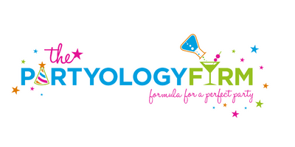
CANCELLATION POLICY
Thanks for booking your party with us!

JUST A FEW LINE ITEMS TO MAKE SURE WE UNDERSTAND OUR PARTY AGREEMENT:
Your deposit holds your date for the event.
If your order is for balloon décor only, full payment is due one week before your event.
If your event includes third party services, such as equipment rental, catering or entertainment, full payment is due 2 weeks prior to event.

Should you need to reschedule your event, PARTYOLOGY FIRM will work with you to pick a new date based on availability. However, this decision must be made at least 14 days prior to the event to receive full credit toward your new date.
If you cancel or postpone your event anytime in between 4 and 13 days prior to your event, you will receive a credit only for those items considered reusable for your new date.
**Please be aware that if you reschedule your party at any time, a new contract, superseding this contract, will be issued and may be subject to an increase in price.

If you cancel your event completely within 3 days of event date, a refund is not possible.

CANCELLATIONS MUST BE MADE BY SENDING AN EMAIL TO LAURA@PARTYOLOGYFIRM.COM AND A PHONE CALL TO 732-297-0031 or 609-601-4227
Please keep a copy of this page for your records.
This page is required with your deposit

CLIENT SIGNATURE:_______________________________________________________

DATE OF EVENT:__________________________________

411 E. 8th St. Ocean City, NJ 08226 PARTYOLOGYFIRM.COM

